**Assignment -4** IBM Cloud - Docker - Kubernets

|  |  |
| --- | --- |
| Assignment Date | 9 October 2022 |
| Student Name | P.Dinesh |
| Student Roll Number | 610519104021 |
| Maximum Marks | 2 Marks |

**Question:**

1. Pull an Image from docker hub and run it in docker playground.
2. Create a dockerfile for the job portal / flask application and deploy it in Docker desktop application.
3. Create a IBM container registry and push docker image of flask application or job portal app.
4. Create a Kubernetes cluster in IBM cloud and deploy flask application image or job portal image and also expose the same app to run in nodeport.

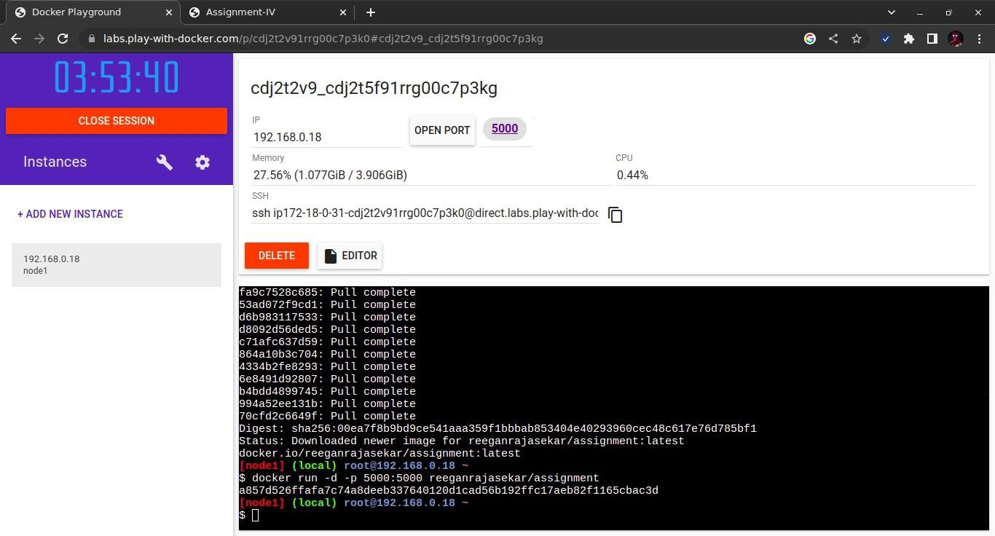

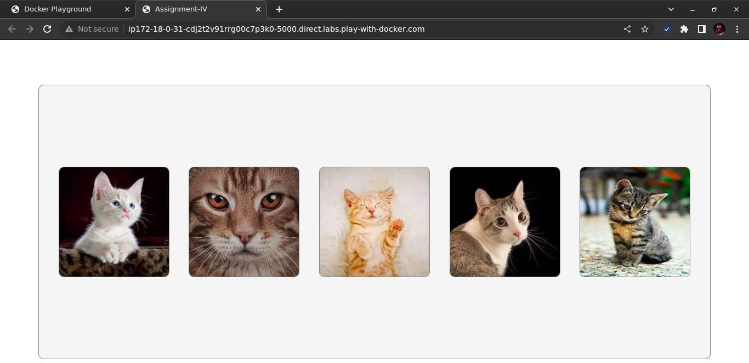

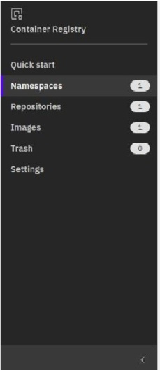Namespaces

Tokyo

Resourcegroup: Filter.. Q Search

D Name

0 D :: assignment_4

Resource group

Default

Repository count Image count

### Retention policy

Retain all images

= Workloads *>* Pods

Repository

**'19** jp.icr.io/assignment_ 4/assignment_4

## Itemsperpage: 25 v 1-loflitem

Image count

Last updated

### 1dayago

1 v loflpage

# Workloads N CPU Usage Memory Usage

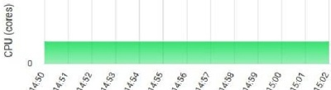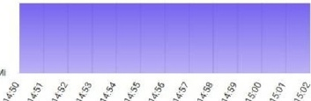Cron Jobs Daemon Sets Deployments

### Jobs

Pods

Replica Sets Replication Controllers

S1atefu1Sets Service

# Pods

Name Images Labels

Node

Status Restarts CPU Usage ( res) :rUsage Created *J*

Ingresses N Ingress Classes Services N

Conf1g and Storage

Conf10Maos JI

## = Workloads

assignment4- Showall

55cd499756-5mnzm

Show all•

Show all Show all•

assignment4- 55cd499756-6ml2n

Show all•

assignment4- Show all 55cd<l99756-tll58f

10.144.194.84

10.144.194.84

10.144.194.84

Running 0

Running 0

Running □

## limir1vl

.<!90

## Uminvl

<!90

## JiminV1J

.<!90

Workloads N Workload Status

Cron Jobs Daemon Sets Deployments Jobs

Pods

Replica Sets Replication Controllers

StatefulSets RuMing:1 Rurmirig:5-

Service Deployments Pods

Ingresses N Ingress Classes Services N

Conf1gandStorage

ConfloMaos *.>i*

Chi tcrs *I*

@assignment O Normc1l Expire5ln3Odny Add tags *t2*

He!p

**f@EEIIWEI**

_LAI,_tio_,_s.._.

v I I

## overview

Exp1resmJ0da

Besuretobackupyourdala yourclusterw1II be deleted 1n ]□days Toaccessthefullcc1pc1b1l1t1esof lryoutc1

ys

thesennce,

Work.err.odes Worker pools

DeVOps '-Jew

ln!lre5,5IIIILI5

1 of 1 0 of 0 Normal Unknown

C, Normal C, Normal "

Details ..1, Details J, Docs ?I Docs ?I

# Details

cdj241,;f08n3dac113tr; '[]

l.24.7_1542 Classic Mi!an01

Re ource group Imagesecurityenf<>rcement

05/11/2022, 14:14 Default I Enable